

ARTIFICIAL INTELLIGENCE

Report on

N-Queens Problem

Under the Guidence of: Dr. Jaylakshmi Banda

Submitted By: Dheeraj Chaudhary (17BCS009)
Priya A Tiru (17BCS021)
Vivek Rai (17BCS033

Contents

1. Problem Statement..............................................................3
2. Solving N-queens Problem.................................................4
2.1 Search Space.............................................................5
2.2 Goal Condition..........................................................5
2.3 Constraints................................................................5
3. Mathematical Formulation.................................................6
4. Solution using Backtracking...............................................7
4.1 Algorithm..................................................................8
4.2 Pseudo Code.............................................................8
4.3 Input/Output of Code................................................9

1. Problem Statement

Using a chess board of N×N size, the challenge is to place N queens on it so that no two queens attack each other.
For example, Using a regular chess board, the challenge is to place 8 queens on the board such that no queen is attacking any of the other.

So one of the solution for above example could be like this:-
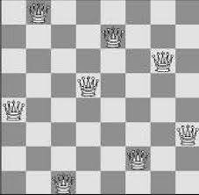

There can be many other solutions for 8 queens and similarly we can change number of queens and board size.

2. Solving N- queens Problem

We cannot use N-queens problem solution, if we have number of queens equal to 3 or 4 we can’t use:

N = 3 or 4
Cannot use N Queens








{ possible soln}

2.1 Search Space: The set of objects among which we search for the solution
Example: N-queen configurations

2.2 Goal condition: This is the characteristics of the object we want to find in the search space?
Example: Non-attacking n-queen configuration

2.3 Constraints
Some contraints are as follows-

There can be only one queen in a column

No two queens will be on the same diagonal.

No queens on the same row.
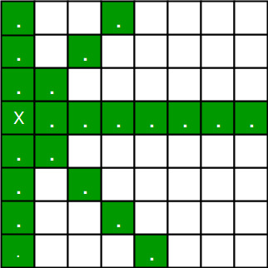

3. Mathematical Formulation

- For N > 4 only
- N is even except N ≠ 6K+2 :
  - Row 1 to N/2: Queen on 2*Row
  - Row N/2+1 to N: Queen on 2*Row-N-1
- N is even, N = 6K+2
  - Row 1 to N/2: Queen on (2*Row + N/2 - 3)mod N +1
  - Row N/2+1 to N: Queen on N - (2*(N-Row+1) + N/2 - 3)mod N
- N is odd:
  - When N is even, no queen is placed on position (1,1).
  - So this just places the first N-1 queens as on an N-1 (even) sized board, then places the last queen on the bottom right position (N,N).



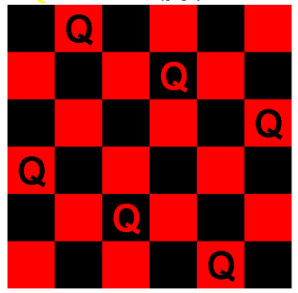

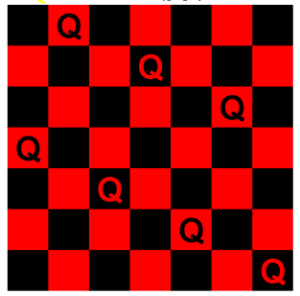

4. Solution Using Backtracking

- One of the approach that guarantees a solution is backtracking, though it can be slow
- It Can be seen as a form of intelligent depth-first search.
- The idea is to place queens one by one in different columns, starting from the leftmost column.
- When we place a queen in a column, we check for clashes with already placed queens. In the current column, if we find a row for which there is no clash, we mark this row and column as part of the solution.
- If we do not find such a row due to clashes then we backtrack and return false.
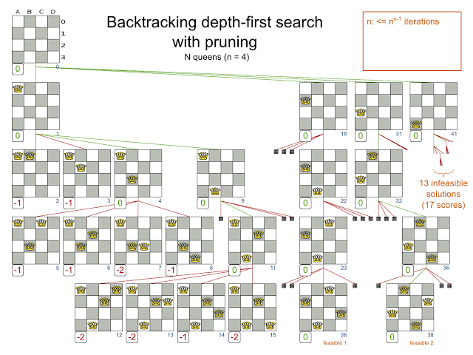

4.1 Algorithms used will be

- Start in the leftmost column
- If all queens are placed
return true
- Try all rows in the current column.
Do following for every tried row.
  - If the queen can be placed safely in this row then mark this [row, column] as part of the solution and recursively check if placing
queen here leads to a solution.
  - If placing the queen in [row, column] leads to a solution then return true.
  - If placing queen doesn't lead to a solution then unmark this [row, column] (Backtrack) and go to step (a) to try other rows
- If all rows have been tried and nothing worked,
return false to trigger backtracking.

4.2 Pseudo code of backtracking in N-queens

IS-ATTACK(i, j, board, N)
// checking in the column j
for k in 1 to i-1
if board[k][j]==1
return TRUE
// checking upper right diagonal
k = i-1
l = j+1
while k>=1 and l<=N
if board[k][l] == 1
return TRUE
k=k+1
l=l+1
// checking upper left diagonal
k = i-1
l = j-1
while k>=1 and l>=1
if board[k][l] == 1
return TRUE
k=k-1
l=l-1
return FALSE

4.3 Input/Output of our submitted code

1. If we give input as N = 1
Output will be 1 solution
2. And for input as N = 2 & 3
Output will be no solution
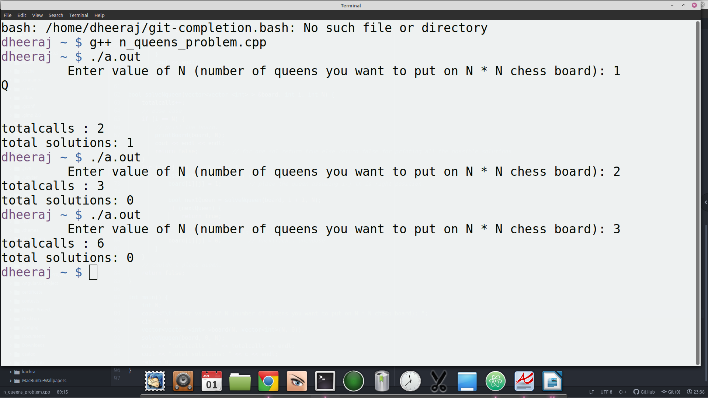

3. If we give input as N = 4
Output will be shown as all possible solution of queens and total number of call for backtraking

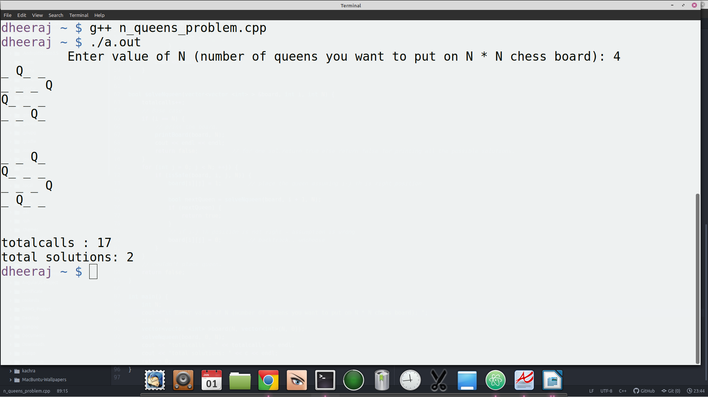
4. Silimary for input N = 8, total solution = 92
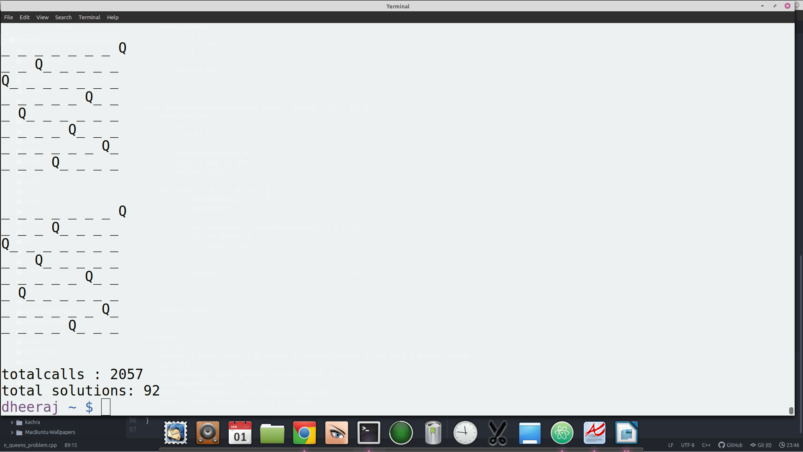

5. As for now possible solutions were known upto N = 27

and our code is running but it will take slightly more than a year time for computation as there are 234907967154122528 solutions of the 27-Queens.

~~~~~~~~~~~~~~~~~~~~~End of Report~~~~~~~~~~~~~~~~~~~~

